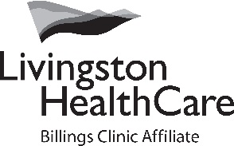
320 Alpenglow Lane
Livingston, MT 59047
www.LivingstonHealthCare.org
(406) 222-3541

REQUEST FOR FINANCIAL ASSISTANCE LHC RURAL HEALTH CLINICS

Please complete the application below and return it with all documentation indicated so we may assist you with your financial responsibility to Livingston HealthCare Rural Health Clinic. List all family members you would like to have considered for financial assistance. Please note that financial assistance cannot be considered for any type of elective medical services.

Financial assistance at Livingston HealthCare will be considered for residents of the state of Montana or established Patients.

Livingston HealthCare cannot guarantee the outcome when applying for financial assistance, but will make every effort to help you resolve your accounts.

Please attach a copy of each of the following:
- A completed, legible financial assistance application
- A copy of patient’s recent federal income tax return. If married and filing separately, the patient should also supply the spouse’s tax return
- A copy of the three (3) most recent pay stubs if employed or other evidence of income (and spouse’s if applicable).
- Copy of the past three months bank statements (savings and checking)

Patient Name: SSN:
Home Address:
Street City State ZIP
Phone Number: (home) (work) (alt.)
Place of Employment:
Spouse Name: SSN:
Spouse Place of Employment:

Dependents:

Name | Age | Name | Age
1. |  | 2.
3. |  | 4.
5. |  | 6.

Monthly Income (gross):
Patient $
Spouse $
Other Financial Support:
$
$
$

Total Monthly Income: $

If you have any questions, please contact a patient financial services representative at (406)823-6414.

Signature:_______________________________________ Date:

Please return this application with all required documentation to:
Livingston HealthCare Financial Counselor
320 Alpenglow Lane
Livingston, MT 59047

