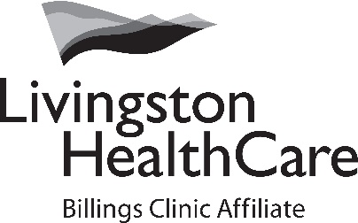

FINANCIAL ASSISTANCE POLICY
PLAIN LANGUAGE SUMMARY

Overview of Financial Assistance
Livingston HealthCare strives to make sure that the financial capacity of people who need health care services does not prevent them from seeking or receiving care. This is a summary of the Livingston HealthCare Financial Assistance Policy (FAP) for Hospital and Rural HealthCare Clinic bills.
Eligibility Requirements
Patients who have the means are expected to pay for services received at Livingston HealthCare.
You may be able to get financial assistance if you do not have insurance, are underinsured, are not eligible for other government programs or assistance (for example Medicare or Medicaid), or if it would be a financial hardship to pay in full the expected out of pocket expenses for services received at Livingston HealthCare Hospital and RHC Clinics.
Eligibility depends on multiple factors, such as but not limited to insurance coverage, Family size, residency, and income.
Current Federal Poverty Level guidelines are used to determine the amount of financial assistance that may be offered.
Patients must fully comply with the application process and providing the requested documentation, such as but not limited to, tax returns, bank statements, pay stubs, as well as completing the required application process for all available sources of assistance, including Medicaid or other Federal Programs.
Exclusions
The policy only applies to medically-necessary services rendered at Livingston HealthCare Hospital and Rural Health Clinics. It does not apply to services rendered by independent physicians or practitioners that are not employed by Livingston HealthCare. This includes but is not limited to outreach physicians, pathologists, radiologists and outside reference labs.
Please Note: Livingston HealthCare Urgent Care Clinic services are already discounted and are not subject to financial assistance.
Where to Find Information
To find information about Financial assistance applications and Policies, or to obtain copies to apply for financial assistance you may:
• Download the information online at livingstonhealthcare.org, by clicking on the financial assistance button on the home screen.
• Request the information in writing by mail or by visiting our Patient Financial Services Customer Service team at Livingston HealthCare 320 Alpenglow Lane Livingston, MT 59047
• Request the information by calling Livingston HealthCare Patient Financial Services Customer Service at 406-823-6414.
How to Apply or receive help completing your application
The application process involves filling out the financial assistance form and submitting the form along with the requested supporting documents to Livingston HealthCare Patient Financial Services 320 Alpenglow Lane Livingston, Mt. 59047
You may also receive help completing your application by visiting our Patient Financial Services Customer Service team at the same address.
Other
No individual who is eligible for financial assistance will be charged more than amounts generally billed (AGB) for emergency or other medically necessary care.

